# **Special Topics** (CSE 490-R)

## Training minutes – Weeks 9-10

|  |  |
| --- | --- |
| **Date:**  **Instructor:**  **Student:** | June 26, 2022  Bro. Clements  Guillermo Oliva |

1. **Prompts from assignment:**

**Part 1: Bugs**

Take one of the bugs you found through testing or review and create a story and add it to the backlog.

|  |  |
| --- | --- |
| **Created from bug** | **Results** |
| As an administrator of the app, I need to ensure that the passport library that provides API authorization is implemented properly, so that I can guarantee that the API will not be exposed to the public.  Complexity: 8 | I encountered this bug while looking at the authorization/authentication code, I had to reimplement the use of passport using JWT. It was failing to protect some API endpoints due to a misconfiguration. |

Include this story in your status

**Part 2: DevOps**

Complete the following:

Research DevOps.

Provide 4-5 websites where you found information:

1. <https://azure.microsoft.com/en-us/resources/cloud-computing-dictionary/what-is-devops/>
2. <https://www.ibm.com/cloud/learn/devops-a-complete-guide>
3. <https://aws.amazon.com/devops/what-is-devops/>
4. <https://www.atlassian.com/devops>

Identify the stages

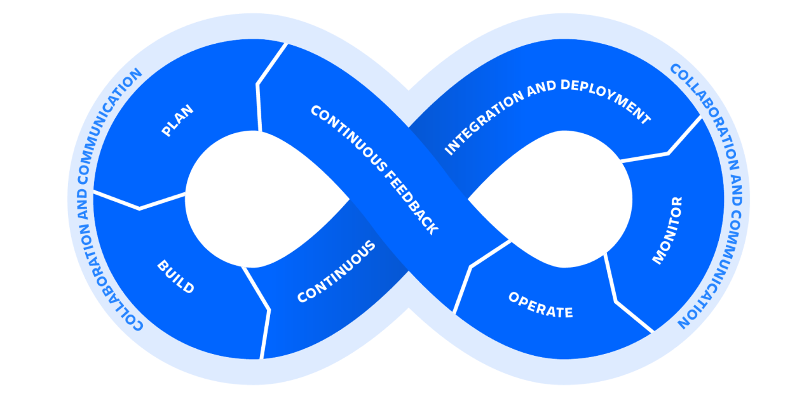

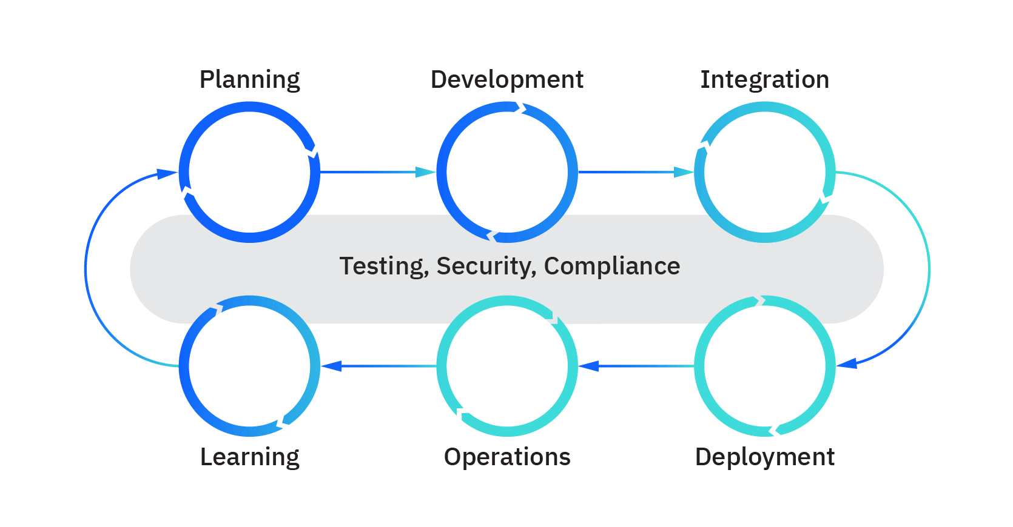

Identify tools that are used in each of the stages

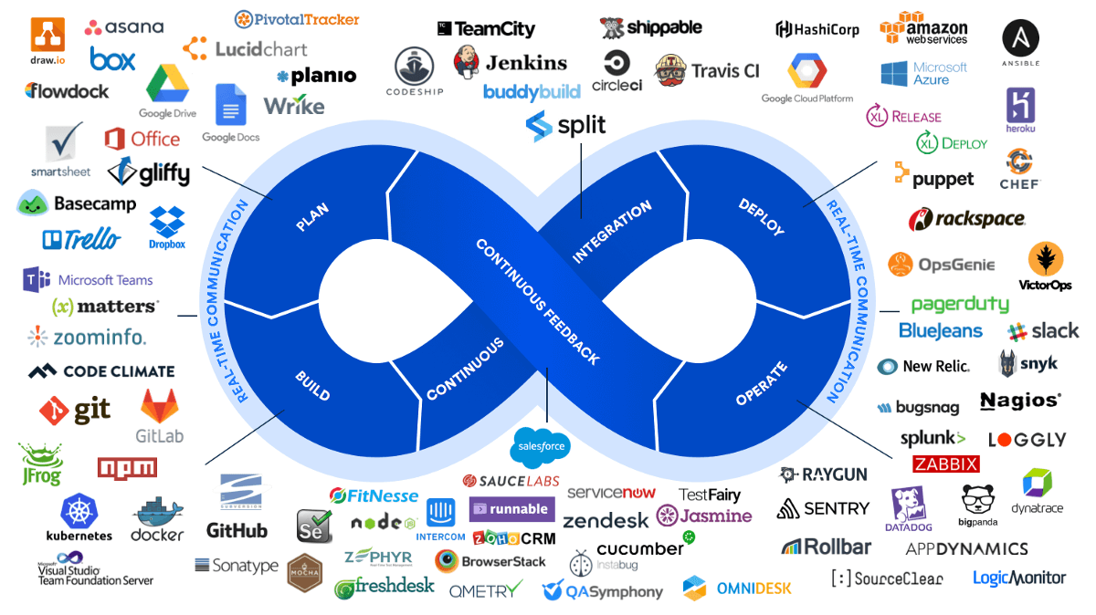

Pick one of the tools and provide a summary of what the tool does.

**Docker** (Source: <https://www.gyansetu.in/what-is-docker-in-devops-how-does-it-work/>)

* It is a unit of code that packages up a new code of an application that the developer is writing and all its dependencies. It makes the application run faster between different computer settings.
* It is an apt solution for software companies that cannot keep up with the pace of changing technology, business, and customer requirements. Developers can write code and share their work with their colleagues using Docker containers.
* Docker can be useful in pushing applications into a test environment to execute automated and manual tests.
* Developers can find and fix bugs in a development environment. Then, redeploy them to the test environment for validation and testing.
* After testing, you can send the fixed application to the customer easily. You can also push updates to the product environment just as easily.

